**Project: Rare and Side Detection for Bicycles and E-bikes**

**Project Concept:**

In this project, two different kinds of Doppler Radar Sensors are used: the RCWL-0561, which has 360 detection angle and range of 5m-7m used for motion detection and HB100 with 160 degrees detection angle and range of 15m.

Three HB100 sensors are installed to cover the blind spots and to measure the speed and direction of the approaching vehicles. The detection range of the device is kept within 5-7ms, which means that data from the hb100 sensors is shown only when the RCWL-0561 detects the movement of any oncoming vehicle. An Arduino Uno is used to process the sensors data, which is then displayed on the mobile app via ESP32 Wi-Fi Module.

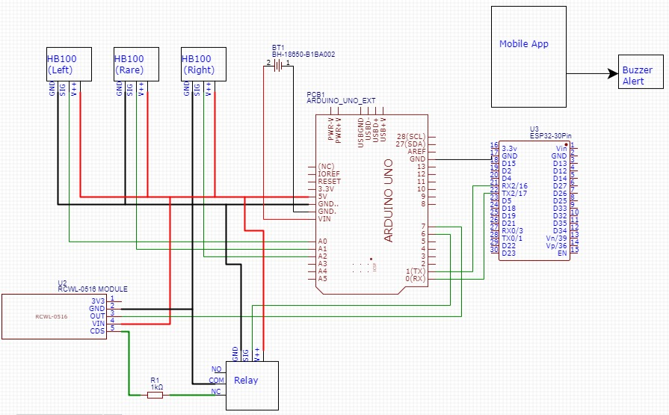

**Hardware Circuitry**

**Sensors Description:**

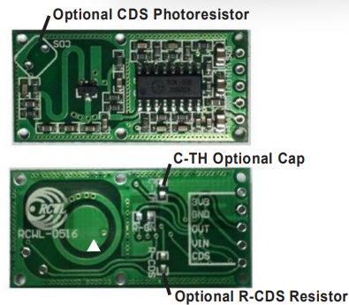RCWL-0561: The sensor consists of a supply pin, a signal pin and a CDS pin

CDS pin is used to vary the detection range of sensor, which is done using a Relay.

The default detection range is 7ms, when the CDS pin is short-circuited using 1M resistor, the range is set to 5ms.

Specifications:

Power: 4-28VDC at less than 3mA.

Detection Range: approximately 5-9m.

Frequency: 3.2GHz.

Transmitting Power: typically 20mW, whereas maximum is 30mW.

Output Level: -3.4V High <0.7 Low Output Drive: ~100mA.

Output Timing: -2sec Retrigger with motion.

Operating Temperature: -20 till 80 Celsius approx.

Storage Temperature: -40-100 Celsius.

Terminals: 0.1 Pitch solder holes.

HB100:

The sensor measures the speed of incoming vehicles. Among the many speed detection methods researched, radar detection did appear to be the most accurate way to detect the speed of approaching vehicles. It is utilized generally in commercial speed guns used by police to check for fast vehicles. The sensor has an oscillator and a mixer. The oscillator generates a sinusoidal signal with a frequency of 10.525 GHz and radiates it, in form of radio wave in one direction using a micro-strip patch antenna, which is thereby reflected back by the running vehicle, and the incoming echo frequency is detected by the built-in receiver. The subtraction of the outgoing and in the incoming frequencies, done via Mixer is then reflected in the IF (intermediate frequency) pin. The frequency of the output signal is proportional to the speed of vehicle. The output is a low amplitude frequency signal in audio range.

The sensor is a 3 pin circuit. Vcc, Gnd and output pin.

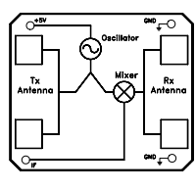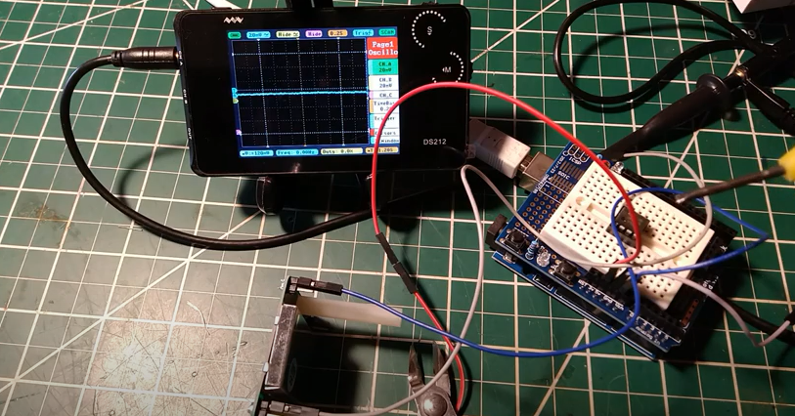

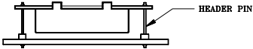

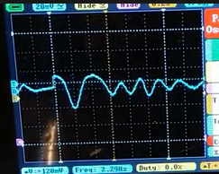

The sensor output changes depending on the object motion.

If the target object is approaching the sensor, the RMS value of the sensor output is positive, whereas it’s negative.

Using the Doppler shift equation to calculate the relation between the shift in frequency and velocity of the moving object.

fd =2*cosA* f * v/c

Where,

fd = shift in frequency in Hz (i.e. frequency of output signal from radar)

v=velocity of moving object

c=velocity of electromagnetic wave in vacuum

f=frequency of transmitted wave from the sensor (10.525 GHz)

Assuming the object is directly ahead so that the value of angle cosA=1, the expression for velocity of the object reduces to:

v= fd /19.49074 km/hour

For v=0, fd = 0

For speed limit of 60 Km/hr., i.e. v=60 Km/hr., output frequency fd=1169.428Hz.

If the output signal of the sensor has frequency exceeding 1169.444Hz, the vehicle exceeds the speed limit of 60 km/hr.

Features:

* 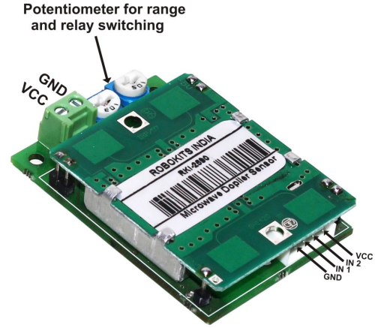Low output current, therefore an Amplifier is used in order to further process the signal.
* CW or pulsed operation
* Flat profile
* Long detection range up to 15m
* Contains potentiometer for range and relay switching duration.
* Output low signal can be used for trig a relay for applications
* Minimum logic low signal is 25 seconds

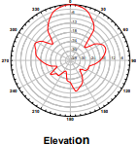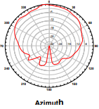Applications:

* Speed measurement
* Motion detection equipment
* Vehicle speed measurement and automatic doors
* Alarms

Amplifier:

Amplifier description:jaydip

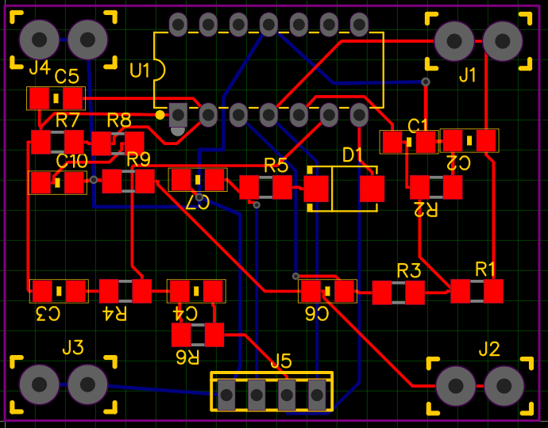

LM324N Amplifier PCB Layout

Micro-Controller:

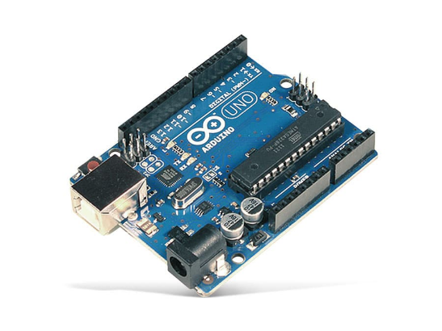

ESP32 Wi-Fi Module:

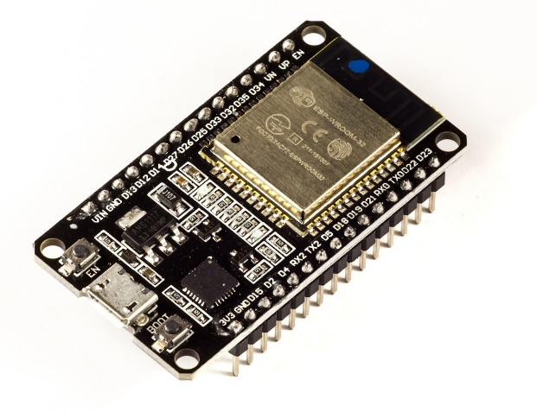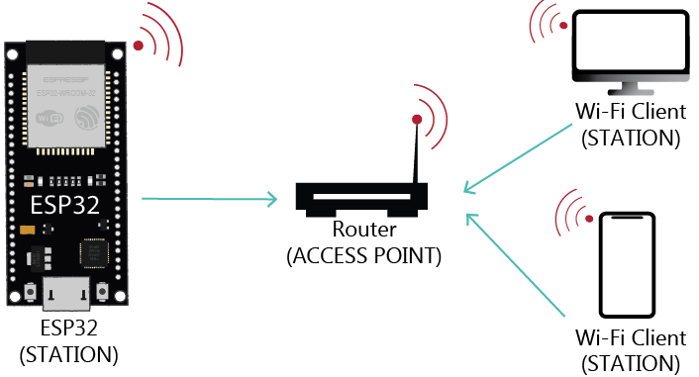

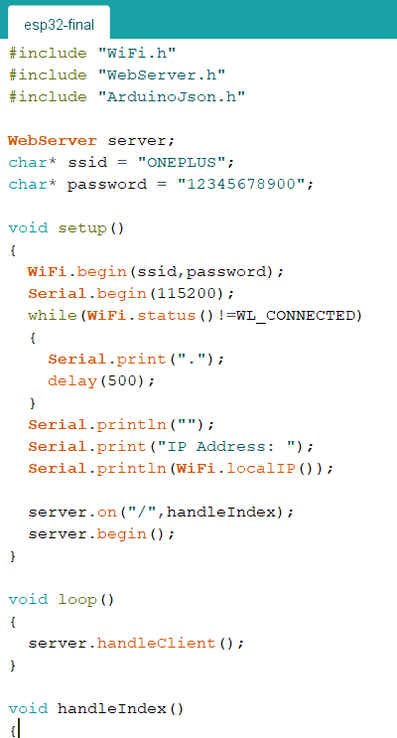

The ESP32 board can act as Wi-Fi Station, Access Point or both. The ssid and password variables hold the SSID and password of the network we want to connect to in this case the rider’s mobile phone.

WiFi.begin() function help in establishing a connection to the network and it is done by passing SSID and password as arguments.The while loop keeps on checking if the connection was already established by using WiFi.status(). When the connection is successfully established, it returns WL_CONNECTED.

When the ESP32 is set as a Wi-Fi station, it can connect to other networks (like your router). In this scenario, the router assigns a unique IP address to your ESP32 board. To get your board’s IP address, you need to call WiFi.localIP() after establishing a connection with your network.

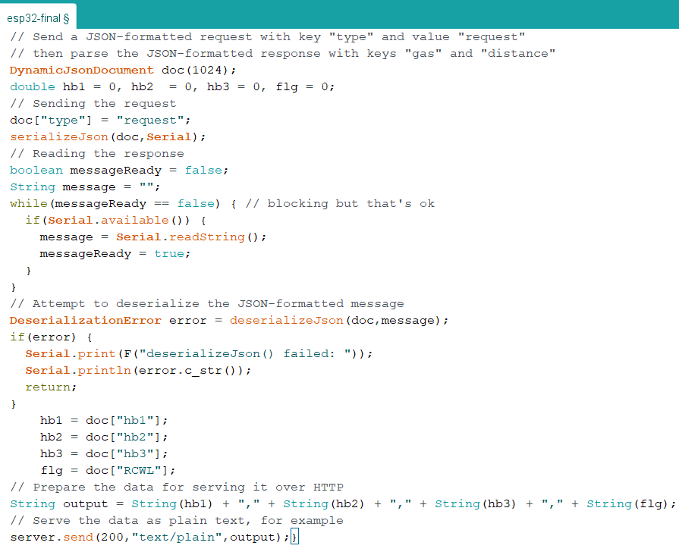The webserver library creates a data channel with the help of the function handleIndex(), creating a handshake between the station and the client.

The handshaking is done by send a JSON formatted request doc. file and getting the response in form of a string.After the handshaking, a boolen messageReady is set to true and sensor data is transmitted to the app.

Output = “hb1” + “hb2” + ”bh3” + ”flag”